Food Product Development Scenario
Food Science and Technology
Career Development Event 2015

*Please Read the Entire Scenario Before Starting!

Your team is in charge of developing an all-natural, gluten-free frozen peanut butter cookie dough. Your product must be formulated for the “all-natural and gluten-conscious consumer” and should not include any ingredients that contain gluten or that are not considered natural. Consider marketing points and nutrient claims that would draw your target audience to your product. You have been provided a starting formula on page 7 that you will need to adjust to make it gluten-free and all natural.

Hand in one complete scenario with the School Name written on the front page. All papers should be returned to the proctor.

Overall Directions:

1. Develop a brand and product name that is consistent with your target market.
2. A)Draw a Principal Display Panel (PDP) for your product. Include all legally required elements. Incorporate your brand and product name. B) Indicate what and where on your Information Panel (IP) you would place all legally required label elements that were not placed on your PDP.
3. Choose from among the ingredients on the attached spreadsheet to prepare your product.
- Use the formula sheet to show your work.
- Use the provided worksheet to explain why you selected these ingredients and how each selection is consistent with your product goals.
Then prepare a Nutrition Facts Panel and Ingredient Statement.
4. Answer the questions 1-3 on page 3.

Scoring (400 pts)
________ All required elements correctly placed on the panels (50 pts)
________ Appealing PDP/Labels (50 pts)
________ Correct Nutrition Facts Panel and Worksheet (125 pts)
________ Correct Ingredient Statement (100 pts)
________ Questions (75 pts.)
TEAM___________________________________

Specifically,
1) Draw a new package design that will best convey the product, including:
(Page 4 - 50 points for locations and 50 points for packaging creativity)
- Statement of Identity - WRITE THE ACTUAL STATEMENT ON YOUR PACKAGE IN THE PROPER PLACE.
- Net Weight Statement - WRITE THE ACTUAL STATEMENT ON YOUR PACKAGE IN THE PROPER PLACE.
- Nutrition Facts Panel - DRAW A BOX AROUND WHERE IT WOULD BE PLACED ON YOUR PACKAGE AND LABEL AS “NFP”.
- Ingredient Statement - DRAW A BOX AROUND WHERE IT WOULD BE PLACED ON YOUR PACKAGE AND LABEL AS “Ingredients”.
- Manufacturer Information - WRITE THE ACTUAL STATEMENT ON YOUR PACKAGE IN THE PROPER PLACE.

2) Fill out the Formula sheet (page 6) and Worksheet (page 7) and use these as well as the Nutritional Information spreadsheet to complete the Nutrition Facts Panel on Page 5 by filling out grams/milligrams and calorie information - 125 points.

NOTE: Nutrition Facts is for a 50 gram ball of unbaked frozen cookie dough and each package contains 24 balls of dough. On this page you DO NOT need to include artwork. Use the attached spreadsheet materials to assist you in your efforts. It is essential to show how you arrived at your results for the Nutrition Facts Panel (Formulation Worksheet)

3) Fill out the Ingredient Statement appropriately (below) - 100 points.

Ingredient Statement:

Ingredients:__________________________________________________________________________________________________________________________________________________________________________________________________________________________________________________________________________________________________________________________________________________________________________________________________________________________________________________________________________

4) Answer the following questions: 25 points each question

- Discuss why the ingredients that you used are considered gluten-free and why you consider the ingredients you selected as “natural”.

- What would be two processing and/or safety issues associated with this product?

- a) If present in a food, what 8 allergens must be clearly listed as an ingredient or in the “Contains” statement? b) Which allergens would be included for the product you have developed?

Package Design with All Elements from Page 2
IP
PDP
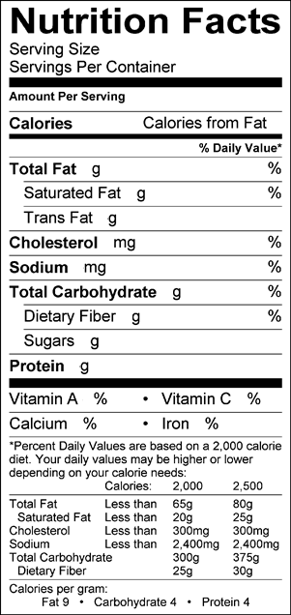
1 cookie ball (50g)
24
Formulation Worksheet
Flour Source (s):______________________________________________________________
Reasoning:___________________________________________________________________________________________________________________________________________________________________________________________________________________________
______________________________________________________________________________
______________________________________________________________________________
______________________________________________________________________________
Peanut Butter Choice(s):__________________________________________________________
Reasoning:___________________________________________________________________________________________________________________________________________________________________________________________________________________________
______________________________________________________________________________
______________________________________________________________________________
______________________________________________________________________________
Other Choice(s) – if used:_________________________________________________________
Reasoning:___________________________________________________________________________________________________________________________________________________________________________________________________________________________
______________________________________________________________________________
______________________________________________________________________________
______________________________________________________________________________

Starting Formula
Ingredient | %
Unsalted Butter | 17.0
Peanut Butter | 19.2
White Sugar | 15.1
Brown Sugar | 16.5
Eggs | 7.5
All-purpose Flour | 23.5
Baking Powder | 0.3
Salt | 0.2
Baking Soda | 0.7

Your Formula
Ingredient | % | Per 50 g  Serving  (g)

